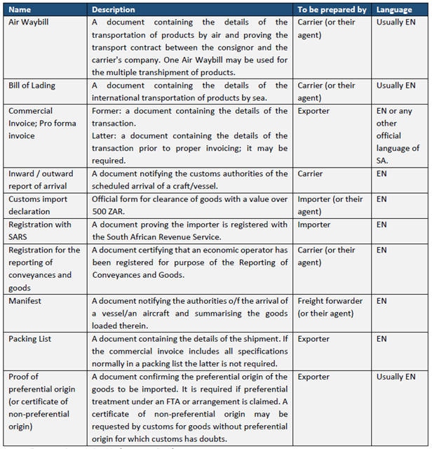
Quelle: European Commission Market Access Database.

