KGCCI M2M Seminar Series 2024
Booklet

chanwit yasamut@Vecteezy.com
As of April 2024

Contact: Young-min Kim
Deputy Director Membership
02-3780-4631 members@kgcci.com
Unlock valuable industry insights and connect with key players at the KGCCI M2M Seminar!
This optimized platform brings together KGCCI members to share cutting-edge knowledge and practical applications. Held every first Tuesday, the seminar offers an invaluable opportunity to:
- Stay ahead of the curve by learning the latest trends and insights from industry experts.
- Expand your network by connecting directly with other professionals in your field.
This comprehensive booklet provides you with a clear overview of the upcoming topics and schedules. Explore it today and see how the KGCCI M2M Seminar can empower your success!

Organization of M2M Seminar
At KGCCI, your voice shapes the M2M Seminar experience! We conduct a member survey in February and August to understand your needs and interests. This valuable input directly influences the selection of speakers and topics, ensuring diversity and relevance. To create a fair and rewarding experience, we prioritize speaker slots based on:
- Diverse perspectives: We aim to cover a wide range of industry topics and trends.
- Premium Partnerships: Recognizing the valuable contributions of our partners.
- Industry relevance: Addressing the most pressing issues and opportunities in your field.
**Let your voice be heard! Participate in the upcoming survey and help define the future of the KGCCI M2M Seminar.

Detailed plan
Date | Topic | Speaker/ Co-host
March 5 | Legal – Data privacy regulation | Ja-young Lee, Yulchon LLC
April 2 | Generative AI | Felix Scharfenberg, Ming Labs
May 7 | Legal – Kab-Eul relationship | Hansung Kang, Seunghyun Min, DLG Law Group
Jun 4 | Legal - Workplace Harassment | Eunjee Kim, Law Firm BKL
July 2 | Tax | Ecovis Han Shin Accounting LLC
August 6 | Saas Platform for ESG | Myung Koo Kang Ph.D., Nuvxx
September 3 | Audit and internal control | Jupyo Seo, BDO Sunghyun
October 1 | AI & application for industrial purposes | Francesco Mercurio, CMC Engineering Melchers
November 5 | Tax | Robert Browell, PwC
December 3 | Energy trend | RWE

KGCCI M2M Seminar in March: Legal
Topic: Latest Updates in Korean Data Privacy Regulations for 2024
Date: March 5
Location: Yulchon LLC
Co-host: Yulchon LLC
Speaker: Ms. Ja-young Lee, Attorney at Law
Details:
Yulchon LLC will provide details of the changes to Korea's data privacy regulations that will come into effect in 2024, the relevant implications, and necessary preparations for business operations.

The session will further provide insight into recent trends and cases from the Personal Information Protection Commission (PIPC) and forecasts for the future under the PIPC's Master Plan for 2024 to 2026.
Registration link: https://kgccide.glueup.com/event/kgcci-m2m-seminar-with-yulchon-llc-100288/

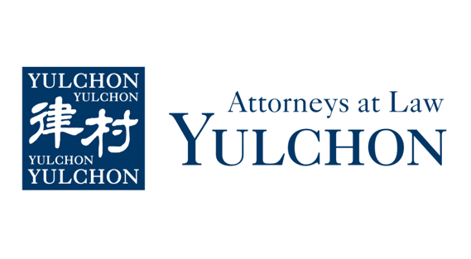

KGCCI M2M Seminar in April: Generative AI
Topic: How to effectively leverage Generative AI in your business
Date: April 2
Location: KGCCI
Co-host: Ming Labs
Speaker: Felix Scharfenberg, Managing Director
Details: In this seminar, MING Labs will introduce the recent developments in Generative AI, and share use-cases, for example on how companies are using GenAI to facilitate sales and to automate back-office processes.

Ming Labs will share learnings on how you can leverage GenAI in your business and what steps to take first.
Registration Link: https://kgccide.glueup.com/event/kgcci-m2m-seminar-with-ming-labs-104222/

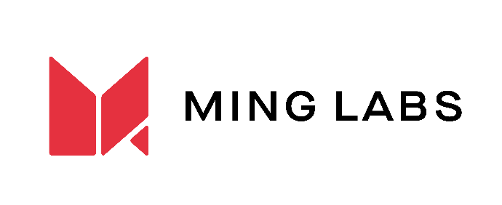

KGCCI M2M Seminar in May: Legal
Topic: Kabeul relataion (top dog vs. underdog) by doing business in Korea
Date: May 7
Location: KGCCI
Co-host: DLG Law Group
Speaker: Hansung Kang, Senior Foreign Attorney
Seunghyun Min, Senior Korean Attorney
Details: This is not a typical competition laws presentation for big multinational companies. The seminar is mainly for foreign SMEs and startups trying to get a foothold in the Korean market. DLG Law Corp., which specializes in assisting SMEs and startups, both Korean and global, will introduce the intricacies of the business and contract negotiations with Korean partners.

In particular, DLG will discuss about how some blatant unfair business practices have led to Korea’s cumbersome fair business practice regulations. Foreign SMEs and startups will need to watch out for some of these regulations, while some regulations can actually protect foreign SMEs and startups from unfair demands or practices of their Korean partners. The seminar will provide some tips in negotiating with Korean companies.
Registration link: https://kgccide.glueup.com/event/kgcci-m2m-seminar-with-pwc-105122/

KGCCI M2M Seminar in June: Legal
Topic: Legal - Workplace Harassment
Date: June 4
Location: Bae, Kim and Lee office
Co-host: Law Firm BKL
Speaker: Eunjee Kim, attorney at law
Details: It is widely known that there is a legal obligation to investigate incidents of workplace harassment once they are reported or when a company becomes aware of such occurrences. However, how should the investigation be conducted practically? What should be taken into account during the process, and how should workplace harassment be determined? Additionally, what are the practical issues related to the involved organization, and how should they be approached? We aim to provide specific tips based on our experiences handling such cases at BKL.
Registeraton link: TBD

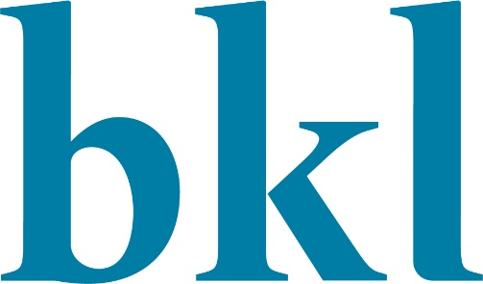

KGCCI M2M Seminar in July: Tax
Topic: Tax
Date: July 2
Location: KGCCI
Co-host: Ecovis Hanshin Accounting LLC
Speaker: TBD
Details: Expanding your business to Korea presents exciting opportunities, but navigating the Korean tax landscape can be complex. Local regulations and ever-evolving policies can lead to unexpected tax challenges for foreign firms.

This informative session, presented by Ecovis Hanshin Accounting, a leading tax firm in Korea, will equip you with the knowledge and confidence you need to ensure tax compliance and avoid potential pitfalls.
Registration link: TBD

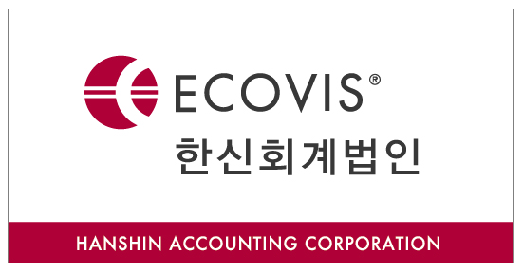

KGCCI M2M Seminar in August: SaaS Platform for ESG
Topic: Carbon Border Adjustment Mechanism (CBAM) for ESG Assessment
Date: August 6
Location: KGCCI
Co-host: NUVXX
Speaker: Myung-Koo Kang, Ph.D., COO
Details:
The Carbon Border Adjustment Mechanism (CBAM) is rapidly becoming a game-changer for global trade. With companies increasingly scrutinized for their environmental impact, demonstrating carbon efficiency is no longer just a sustainability goal, it's a business imperative.

This timely seminar tackles both challenges and solutions. We'll explore the intricacies of CBAM and its implications for your company's ability to export to the EU. More importantly, we'll introduce NUVXX, a leading provider of innovative SaaS platforms.
Registration link: TBD

KGCCI M2M Seminar in September: Audit and internal control
Topic: Data-driven fraud detection audit and internal control
Date: September 3
Location: KGCCI
Co-host: BDO Sunghyun
Speaker: Jupyo Seo, Director of Digital Audit Division
Reason to attend:
In this seminar, BDO Sunghyun will introduce cases where appropriate internal controls and data-driven monitoring successfully detected and uncovered signs of irregularities, which have been a rising issue within Korean companies recently.

Agenda:
1) Risk related to major fraud cases
2) Potential fraud risks within organization and data-driven internal audit methodology
3)Regular monitoring for signs of irregularities through the establishment of internal control
Registration link: TBD

KGCCI M2M Seminar in October: Supply Chain Optimization using AI
Topic: AI & application for industrial purposes
Date: October 1
Location: KGCCI
Co-host: Melchers CMC Engineering
Speaker: Francesco Mercurio
Details: This seminar is an opportunity to explore how AI can be harnessed as an effective tool for enhancing compliance in the realms of ESG.

ESG compliance in business is no longer just an option but a requirement toward a successful business model and international standards.

In this seminar, we will discuss how AI supports ESG compliance through various means such as data analytics, predictive analysis, automated reporting, natural language processing and much more.
Registration link: TBD

KGCCI M2M Seminar in November: Tax
Topic: Tax
Date: November 5
Location: KGCCI
Co-host: PwC Samil
Speaker: Robert Browell
Details: Navigating the Korean corporate tax landscape can be challenging, especially for foreign firms facing rapid policy changes. In a post-election environment, these uncertainties can significantly impact your business operations.

This insightful seminar leverages PwC's global expertise and combines it with PwC Samil's deep understanding of the Korean market. This powerful combination will provide you with the clarity and guidance you need to thrive.
Registration link: TBD

KGCCI M2M Seminar in December: TBD
Topic:
Date: December 3
Location: KGCCI
Co-host:
Speaker: TBD
Details: TBD
Registration link: TBD

Please note, the KGCCI M2M Seminar schedule and content is subject to change.

