Samichlaus / Nikolaus visit during the
Swiss Christmas Brunch
8 December 2018 at 13.30 hrs

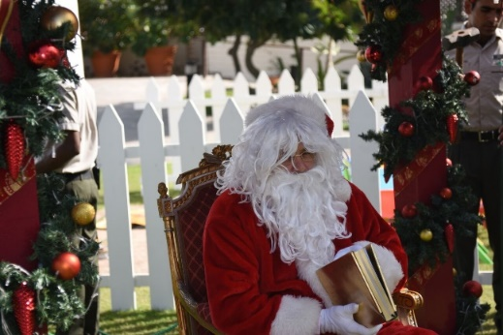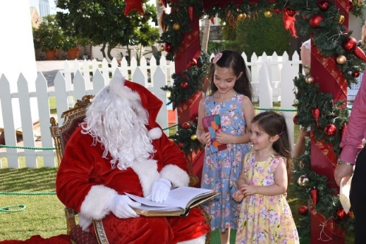

1 Form per Child
Please complete the form on the computer (not handwritten) in the language that Samichlaus / St. Nikolaus should speak to your child:
English, French, German or Swiss German

--------------------- Registration slip ----------------------

Name of child: Age:
__________________________ __________________________

What should Samichlaus / St. Nikolaus mention to your child:

__________________________________________________________

__________________________________________________________

__________________________________________________________
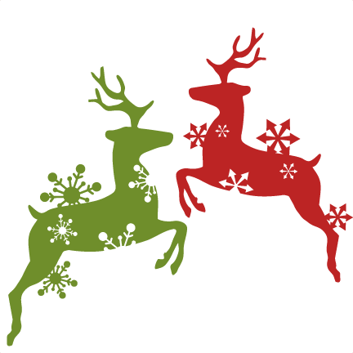

__________________________________________________________

__________________________________________________________

Please return the duly filled form by email to Ms. Charoline Engel abudhabi@swissbcuae.com to reserve a gift bag for your child by 6 December 2018 at the latest.

Your confirmation is binding and cancellations after the 6 December 2018 as well as no-shows will be invoiced the full amount. Tickets cannot be refunded.

